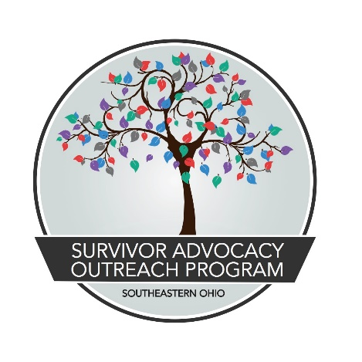

JOB TITLE: Advocate/Crisis Intervention Specialist
REVISED: August 15, 2021
REPORTS TO: Direct Service Supervisor
CLASSIFICATION: Full Time, (1.0 FTE) exempt (to include evening and weekend work as the program demands). The position is grant funded and contingent on the availability of new and continuing grant funding.
JOB SUMMARY:
Advocate/Crisis Intervention Specialist (ACIS) is an exempt full-time (1.0 FTE), benefits eligible position tasked with providing direct service provision and coordination of community response regarding sexual violence, dating/ domestic violence, human trafficking, and stalking. General duties include, but are not limited to, providing services to survivors during regular office hours and scheduled periods of evening/overnight response for face-to-face and phone/hotline advocacy. Duties can include responding to emergency departments, police stations, social service organizations, and other safe spaces to assist survivors and execute trauma-informed crisis stabilization techniques.

SALARY & BENEFITS:
Base salary is $37,440 per year with health expense stipend ($433.33 single with no dependents/$883.33 married or has dependents), 5% base salary pension contribution (employer sponsored), short/long-term disability and life insurance (employer sponsored), 80 hours of PTO per quarter, and work related travel reimbursements ($.45 per mile).

QUALIFICATIONS:
- Minimum of a Bachelor’s Degree and 1-year experience in case management, crisis intervention and working knowledge/expertise of trauma/ survivorship or equivalent combination of education and experience.
- Excellent verbal and written communication skills; valid driver's license, good driving record, and vehicle suitable for transportation
- Weekend, evening, holiday, and overnight availability
- Good written and verbal communication skills,
- Self-motivated and independent working abilities,
- Ability to create and maintain working relationships with community organizations
- Knowledge of sexual victimization and survivor services
- Advocacy and crisis intervention skills

Attendance of required trainings
ACIS is responsible for the following within designated community and others as needed. Duties, responsibilities and activities may change or new ones may be assigned at any time with or without notice.
- Provision of direct services to survivors of sexual assault, intimate partner violence, human trafficking, and stalking. Services can include:
  - Mobile Advocacy
  - Transportation
  - Advocacy/ Accompaniment
  - In-Person and Hotline Advocacy
  - Legal/ law enforcement Advocacy
  - Medical Advocacy
  - Personal Advocacy
  - Crisis Intervention/Stabilization
  - Service Coordination and Referral
- Staff 24-hour crisis hotline on-call and backup shifts
  - Answer the hotline on designated shifts and activate to provide in-person (maximum 30-minute response time) or over-the-phone advocacy services
  - Provide back up support to volunteers/interns who take hotline shifts and facilitate forwarding hotline calls to appropriate individual
- Establishing and coordinating relationships with community organizations
- Working to create a coordinated community response to violence within the communities
  - Establishing SART/MDTs/task forces as needed
- Providing education, support groups, and awareness regarding sexual violence
  - establish and facilitate workshops to raise awareness and educate regarding sexual violence
  - Coordinate and facilitate support groups for survivors
  - Attend/organize tabling events, women’s health fairs, community fairs, and other events within the community to raise awareness regarding SAOP services and sexual violence
- Creating and distributing outreach materials
  - Evaluate, update, and re/create brochures, survivor service manuals, and fliers regarding SAOP services and information pertaining to sexual violence for distribution throughout communities
  - Maintain relationships with social service providers and community resources to ensure outreach materials are available and displayed throughout the communities
  - Create, distribute, and promote outreach materials for awareness raising months and events
- Other duties as assigned.

OTHER DUTIES:
- Maintain accurate records of services provided to clients
- Maintain participation in state and regional networks
- Continue professional development
- Participate in ongoing education requirements in compliance with Rape Crisis Center standards
- Work closely with other client service providers/SAOP staff on cases requiring multidisciplinary services
- Support SAOP volunteers and interns as needed
- Report scheduling conflicts, problems, or other concerns to direct supervisor

Survivor Advocacy Outreach Program is an Equal Opportunity Employer that does not
discriminate on the basis of actual or perceived race, creed, color, religion, lineage or national origin, ancestry, citizenship status, age, ability, sex, gender, marital status, veteran status, sexual orientation, genetic information, arrest record, or any other characteristic protected by applicable federal, state or local laws.

All full-time staff receive employer sponsored retirement plan contributions, health related expense stipend, and generous paid-time off. These benefits are reflective of SAOP being committed to trauma-informed care not only with our clients, but also our staff.

