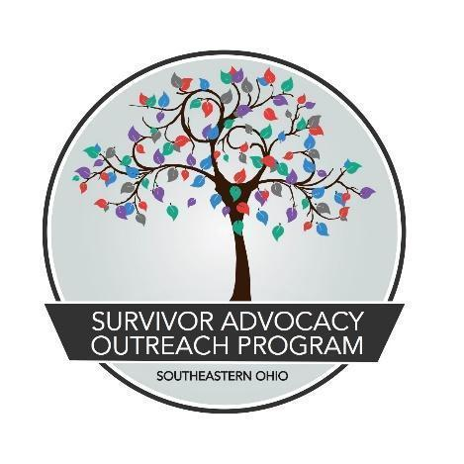

JOB TITLE: New Leaf Case Manager
REVISED: December 1, 2022
REPORTS TO: Supportive Services Program Manager
CLASSIFICATION: Full Time, (1.0 FTE) exempt (to include evening and weekend work as the program demands). The position is grant funded and contingent on the availability of new and continuing grant funding.
TO APPLY: Submit a detailed cover letter, resume, and three professional references to Madison Trace via email at madison@saopseoh.org by December 23, 2022. Interviews will take place at SAOP’s main office in Athens, Ohio.

JOB SUMMARY:
The New Leaf Case Manager is responsible for weekly case management of all program participants ensuring each are meeting program requirements, have access to timely services provided by qualified mental health therapists and medical/dental needs. The Case Manager will provide supervision, oversight, and support to program participants at the New Leaf Marketplace. In addition, the New Leaf Case Manager screens applicants to the program, following program guidelines. The Case Manager is responsible for managing outreach to community providers, and related social service agencies as well as to potential clients.

SALARY & BENEFITS:
Base salary is $40,040 per year with monthly health expense stipend ($454.16 single with no dependents/$920.83 married or has dependents), 5% base salary pension contribution (employer sponsored), short/long-term disability and life insurance (employer sponsored), 80 hours of PTO per quarter, and work related travel reimbursements ($.58 per mile).

QUALIFICATIONS & REQUIRED SKILLS:
- Bachelor’s degree in human services, social services or a related field or years of experience will be considered in lieu of a degree.
- At least three (3) to five (5) years’ experience in working directly in social services, including direct contact with vulnerable populations, preferably with a non-profit organization.
- Strong team building skills, proven project management skills, ability to allow autonomy without micro-managing. This includes managing and guiding group efforts as well as organizational efforts.
- Excellent reading, analyzing, speaking, writing and interpersonal communication skills.
- Developed and professional interpersonal skills, attitude and appearance.
- Prior experience in a similar role or extensive experience within a non-profit is highly desired.
- Requires detailed oriented individual with the ability to apply complex policies and procedures within parameters given.
- Proven track record working with clients/residents, employees/volunteers, donors and the community.
- Demonstrated ability to use initiative and resources to guide, advise and help residents as well as prioritize and handle competing priorities.
- Intermediate to advanced skill level in computer software including Word, Excel, Outlook, and all MS Office Suite-all versions.
- Proactive approach that is looking for ways to maintain and improve processes and help people by applying creativity and flexibility to achieve outcomes.
- Ability to pass a Background check.
- Possess and maintain current Driver’s license and retain auto insurance as law requires.

ESSENTIAL DUTIES:
- Work involves planning, developing, implementing, and monitoring access and eligibility to social service programs.
- Coordinates delivery of services through effective management of resources.
- Provides supervision, oversight, and support to program participants at the New Leaf Marketplace.
- Completes essential job duties at the New Leaf Marketplace when program participants need support doing so or are not able to complete the duties for whatever reason.
- Collects, organizes, analyzes, and prepares material in response to requests for information, complaints, and reports.
- Oversee timely collection of accurate resident documentation and program service data.
- Create and maintain community partnerships, community groups and agencies as required.
- Identify measures of success, including participant satisfaction and program effectiveness in conjunction with other staff members and Executive Director.
- Maintains all program participant records by reviewing case notes; logging events and progress.
- Develop a climate providing motivation, participation and opportunities for participants to thrive in community living and recovery.
- Maintain drug and alcohol-free home.
- Ability to work in a constant state of alertness and safe manner.
- Establish good working relationship with other team members.
- Foster positive communications and relationships with residents, staff and community members.
- Keep up to date on industry trends and developments.
- Adhere to company policies and procedures.
- Actively participate in meetings as requested.
- Other duties as assigned.

OTHER DUTIES:
- Maintain accurate records of services provided
- Maintain participation in state and regional networks
- Continue professional development
- Work closely with other client service providers/SAOP staff on cases requiring multidisciplinary services
- Support SAOP volunteers and interns as needed
- Report scheduling conflicts, problems, or other concerns to direct supervisor
- Participate in ongoing education specifically addressing oppression and racism for a minimum of five hours per month

Survivor Advocacy Outreach Program is an Equal Opportunity Employer that does not
discriminate on the basis of actual or perceived race, creed, color, religion, lineage or national origin, ancestry, citizenship status, age, ability, sex, gender, marital status, veteran status, sexual orientation, genetic information, arrest record, or any other characteristic protected by applicable federal, state or local laws.

All full-time staff receive employer sponsored retirement plan contributions, health related expense stipend, and generous paid-time off. These benefits are reflective of SAOP being committed to trauma-informed care not only with our clients, but also our staff.

