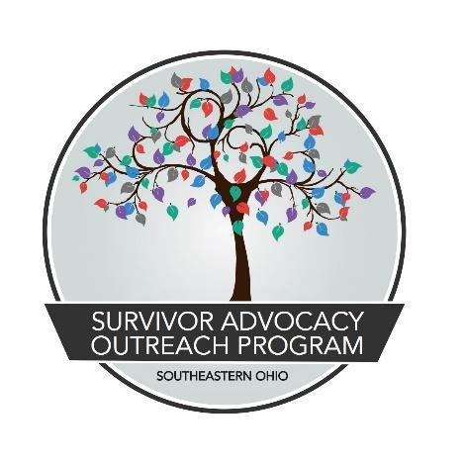

JOB TITLE: Childcare Coordinator/Provider
REVISED: October 21, 2022
REPORTS TO: Youth Resilience Program Manager
CLASSIFICATION: Full Time, (1.0 FTE) exempt (to include evening and weekend work as the program demands). The position is grant funded and contingent on the availability of new and continuing grant funding.
TO APPLY: Submit a detailed cover letter, resume, and three professional references to Madison Trace via email at madison@saopseoh.org by January 15,2022. Interviews will take place at SAOP’s main office in Athens, Ohio
JOB SUMMARY:
Childcare Coordinator/Provider is an exempt full-time (1.0 FTE), benefits eligible position tasked with coordination, implementation, and oversight of the child care program for SAOP. This position will be responsible for the care of the children of the New Leaf program participants and the general public, ensuring a trauma informed approach to programming and caregiving. May serve as a supervisor of other childcare providers as needed.

SALARY & BENEFITS:
Base salary is $40,060 per year with health expense stipend ($433.33/month single with no dependents/$883.33/month married or has dependents), 5% base salary pension contribution (employer sponsored), short/long-term disability and life insurance (employer sponsored), 160 hours of PTO per year, and work related travel reimbursements.

QUALIFICATIONS & REQUIRED SKILLS:
- HS Diploma or GED (required) Associates in Childhood Development or related field (preferred).
- Excellent verbal and written communication skills; valid driver's license, good driving record, and vehicle suitable for transportation
- Weekend, evening, holiday, and overnight availability
- Excellent reading, writing, and verbal communication skills
- Demonstrates excellent active listening skills
- Knowledge of culturally humble services and developmentally appropriate, trauma and crisis intervention
- Understands the importance of trauma-informed care and is willing to build programming based on these standards
- Possesses the ability to keep children engaged and safe
- Possesses the ability to make sound judgments as well as strong decision making skills.
- Complete the process for a licensed Type B home provider and maintain good standing with ODJFS licensing requirements.
- Strives to achieve a minimum of a 3 star rating with the ODJFS Step Up To Quality

ESSENTIAL DUTIES:
- Adopts and implements a research based curriculum that includes daily lesson plans that will be based on each child’s developmental needs and organizes activities designed to help children learn about their world and further their development.
- Monitors and supervises children keeping them safe and healthy.
- Helps children maintain good hygiene and changes diapers and assists with handwashing, toileting and toilet training
- Creates schedules to ensure that children have adequate physical activity, rest, nutrition, and intellectual stimulation.
- Administers developmental assessments and shares information with parents
- Keeps records of children’s routines throughout the day.
- Transports children to summer activities like swimming lessons, sports practices and movies
- Maintains all health and safety standards as required by ODJFS guidelines
- Complete documentation and submit billing for TitleXX reimbursement

OTHER DUTIES:
- Maintain accurate records of services provided
- Maintain participation in state and regional networks
- Continue professional development
- Work closely with other client service providers/SAOP staff on cases requiring multidisciplinary services
- Support SAOP volunteers and interns as needed
- Report scheduling conflicts, problems, or other concerns to direct supervisor
- Maintain the areas dedicated to childcare in a sanitary, orderly way free from clutter and debris
- Participate in ongoing education specifically addressing oppression and racism for a minimum of five hours per month

Survivor Advocacy Outreach Program is an Equal Opportunity Employer that does not
discriminate on the basis of actual or perceived race, creed, color, religion, lineage or national origin, ancestry, citizenship status, age, ability, sex, gender, marital status, veteran status, sexual orientation, genetic information, arrest record, or any other characteristic protected by applicable federal, state or local laws.

All full-time staff receive employer sponsored retirement plan contributions, health related expense stipend, and generous paid-time off. These benefits are reflective of SAOP being committed to trauma-informed care not only with our clients, but also our staff.

Revised 10/22

